
Journal of Advanced Zoology
ISSN: 0253-7214
Volume 45 Issue 2 Year 2024 Page 395-406

__________________________________________________________________________________________________________________
Anti-Diabetic Evaluation Of The Traditional Siddha Polyherbal Formulation - Madhu Mukthi Kudineer Chooranum By In Silico Analysis

Dr. Baskar Rajamanickam^{1*}, Dr. Bharathkumar Govindaraju², Dr. Selvapriya Sikkal Selvaraaju³, Dr. Hemadevi Thangarasu⁴, Dr. Shameem Fathima Abdul kareem.⁵

^{1*}Lecturer II, Department of Gunapadam (Pharmacology), Government Siddha Medical College, Chennai, Tamil Nadu, India.
².Assistant Professor, Department of Siddha, The Tamil Nadu Dr. MGR Medical University, Chennai, Tamil Nadu, India.
³PG Scholar, Department of Siddhar Yoga Maruthuvam, Government Siddha Medical College, Chennai, Tamil Nadu, India.
⁴Assistant Medical Officer, Aringnar Anna Govt Hospital of Indian Medicine, Chennai, Tamil Nadu, India.
⁵Lecturer II, Department of Udal Thathuvam (Physiology), Government Siddha Medical College, Chennai, Tamil Nadu, India.

*Corresponding author: Dr. Baskar Rajamanickam
*Lecturer II, Department of Gunapadam (Pharmacology), Govt. Siddha Medical College, Chennai, Tamil Nadu, India Email: drbaskarmd06@gmail.com

CC License  CC-BY-NC-SA 4.0 | Abstract:  Background: From ancient times Siddha medicines have been proven to treat a wide range of communicable and noncommunicable diseases. In India, the number of people affected with diabetes is increasing drastically and it is considered as an epidemic.  Purpose: To assess the anti-diabetic activity of the active compounds of the polyherbal formulation – Madhu Mukthi Kudineer Chooranum (MKC) by docking against potent enzymes involved in diabetes mellitus by in silico method.  Methods: The major target enzymes Dipeptidyl peptidase, Glycogen synthase kinase - 3β, Alpha-glucosidase and Alpha-amylase were docked against the 10 active compounds present in the MKC using Auto Dock tools.  Conclusion: The strong interactions between the target enzymes and the active compounds proved the anti-diabetic efficacy of the MKC formulation. Thus, the intake of MKC has potential benefits in the treatment of Type II Diabetes Mellitus.

Introduction

Siddha medicine is a holistic system of healthcare that originated in South India thousands of years ago. The word Siddha originated from the word Siddhi meaning “perfection” or “to achieve. It is based on the principles of Ayurveda and emphasizes the use of natural remedies to promote healing and balance in the body. The Siddha system is known for its effectiveness in treating a wide range of ailments, from common colds and fevers to chronic diseases like diabetes and arthritis. By harnessing the power of nature and working with the body's healing mechanisms, Siddha medicine offers a safe and effective alternative to conventional medicine (Dr.R.S. Lekshmi1, Dr.K. Jawaharrani2, Dr.J.Srilekha3 2023; Mandal et al. 2023; Palpandian 2019, n.d.).
In Siddha, diabetes mellitus is termed as Madhumegam meaning “honey urine”. In India, 62 million people have acquired diabetes and as per a recent statistics report by the International Diabetes Federation (IDF), it is estimated that 70 million people will acquire diabetes by 2025 if proper awareness is not adopted. Along with the diabetic complications, it is also associated with several chronic illnesses. It also damages kidneys, eyes, and nerves, and increases the risk of leg amputation and loss of vision (Maiti et al. 2023; Saravana Babu et al. 2012).
There are various enzymes like dipeptidyl peptidase IV, Glycogen synthase kinase beta, alpha-glucosidase, and pancreatic alpha-amylase involved in the progress of diabetes mellitus (Oboh et al. 2014). Overexpression of these genes weakens the insulin signaling mechanism and downregulates the insulin receptor substrate – 1. This leads to insulin resistance and elevates the blood glucose level (type 2 diabetes). Therefore, it has been proposed that the drugs that can inhibit these enzymes will mimic the insulin activity to convert glucose to glycogen and prevent insulin resistance. Though current treatments are effective they do have lots of limitations (Ponnusamy et al. 2022). Thus, early detection, awareness, treatment, and maintenance of blood sugar levels are the need of the hour.
In silico methodologies serve to be an excellent tool to understand the mechanism of action of potential phytochemicals against the target enzymes by predicting the drug-protein interaction and helping to identify the potential molecule for therapeutic purpose (Raut et al. 2023). In this present study, a polyherbal antidiabetic formulation was prepared using a concoction of herbs termed Madhu Mukthi Kudineer Chooranum collected from the literature (Mudaliyar n.d.; New Delhi, Govt.of India, Ministry of Health and Family welfare 2011). The major phytochemicals of the selected herbs were docked with the respective enzyme inhibitors and their anti-diabetic ability was analyzed. With this advanced technology, a specific drug formulation can be used to treat the diabetes mellitus.

Materials and Methods

Procurement of plant material and preparation of Madhu Mukthi Kudineer Chooranum
The required bark and roots were collected from the natural habitat at Jolarpettai and the foothills of Yelagiri. The raw drugs were authenticated by the Department of Pharmacognosy, Siddha Central Research Institute, Chennai-106 and mentioned in table 1. Raw drugs were taken and purified as per Siddha's text. The plant samples were taken in the required proportion as mentioned in Table 1 and coarsely powdered. To 6 g of this powder 240 ml of water was added and allowed to boil until 60 ml and this decoction should be consumed daily on an empty stomach both in the morning and evening.
Note: Food should not be ingested for 20 min after administering the medicine.

Table 1. List of plant samples selected for the preparation of Madhu Mukthi Kudineer Chooranum (MKC)
Sl.No | Plant Samples | Parts used | Quantity
1 | Salacia oblonga Wall. | Root | 4 parts
2 | Azadirachta indica A.Juss. | Stem bark | 3 parts
3 | Aegle marmelos (L.) Correa | Root | 3 parts
4 | Tinospora cordifolia (Willd.) Miers ex Hook.f. & Thomson | Stem | 2 parts
5 | Cassia fistula L. | Stem bark | 1 part

Docking studies
The major phytochemicals selected from the different herbs of MKC will be examined for their potential as an antidiabetic drug by docking studies. The target protein structures of the enzymes were taken from the protein data bank and the required hydrogen bonds that were lost during clean-up process were added. Different orientation of the lead molecules concerning the target protein was evaluated by Autodock program and the best dock pose was selected based on the interaction study analysis.

Table 2. List of Phytocomponents Selected for Docking
Herbs | Phytochemicals | References
Salacia Oblonga | Salacinol  Kotalanol | Sujata Basu. Phytochemical Evaluation And Hplc Profiling Of Extracts of Salacia oblonga. International Journal of Pharmaceutical Sciences and Research 4(4):1409-1418 (Sujata, Pant, and Rachana 2013)
Azadirachta indica | Nimbolide  Nimbiol | Alzohairy MA. Therapeutics Role of Azadirachta indica (Neem) and Their Active Constituents in Diseases Prevention and Treatment. Evid Based Complement Alternat Med. 2016;2016:7382506 (Alzohairy 2016)
Aegle marmelos | α-Humulene  Umbelliferone | Shahedur Rahman and Rashida Parvin. Therapeutic potential of Aegle marmelos (L.)-An overview. Asian Pac J Trop Dis. 2014 Feb; 4(1): 7177 (Rahman and Parvin 2014)
Tinospora cordifolia | Tinosporide  Tembetarine | Krupanidhi S, Abraham Peele K, Venkateswarulu TC, et al. Screening of phytochemical compounds of Tinospora cordifolia for their inhibitory activity on SARS-CoV-2: an in silico study .J Biomol Struct Dyn. 2020;1-5 (Krupanidhi et al. 2020)
Cassia fistula | Linoleic acidKaempferol | Rahmani AH. Cassia fistula Linn: Potential candidate in the health management. Pharmacognosy Res. 2015;7(3):217-24 (Rahmani 2015)

Docking calculations were carried out for retrieved phytocomponents against target enzymes dipeptidyl peptidase IV, Glycogen synthase kinase beta, alpha-glucosidase, and pancreatic alpha-amylase. Essential hydrogen atoms, Kollman united atom type charges, and solvation parameters were added with the aid of AutoDock tools (Morris, Goodsell et al., 1998). Affinity (grid) maps of ×× Å grid points and 0.375 Å spacing were generated using the Autogrid program (Morris, Goodsell et al., 1998). Auto Dock parameter set- and distance-dependent dielectric functions were used in the calculation of the van der Waals and the electrostatic terms, respectively. Docking simulations were performed using the Lamarckian genetic algorithm (LGA) and the Solis & Wets local search method (Solis and Wets, 1981). Initial position, orientation, and torsions of the ligand molecules were set randomly. All rotatable torsions were released during docking. Each docking experiment was derived from 2 different runs that were set to terminate after a maximum of 250000 energy evaluations. The population size was set to 150. During the search, a translational step of 0.2 Å, and quaternion and torsion steps of 5 were applied (Lakshmanakumar et al. 2023).

Results and Discussion
From the selected herbs for the preparation of MKC, a total of 10 bioactive lead compounds Salacinol, Kotalanol, Nimbolide, Nimbiol, α-Humulene, Umbeelliferone, Tinosporide, Tembetarine, Linoleic acid, Kaempferol. The 2D and 3D structures of the phytocomponents and the standards sitagliptin, GSK -3β Inhibitor VII, Acarbose were retrieved and represented in Fig 1 and their ligand properties are mentioned in table 3. The retrieved structures were docked against Dipeptidyl peptidase, GSK-3β, alpha-glucosidase and alpha-amylase.

Figure 1 2D and 3D Structure of Phytocomponents and the standards selected for docking
Salacinol
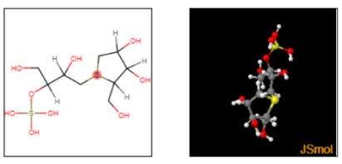

Kotalanol
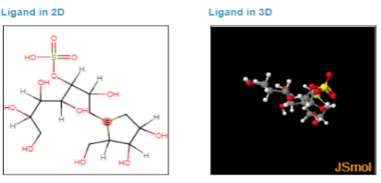

Nimbolide
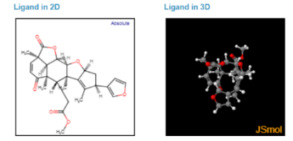

Nimbiol
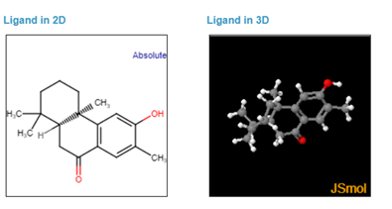
α-Humulene
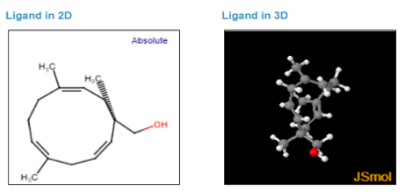
Umbelliferone
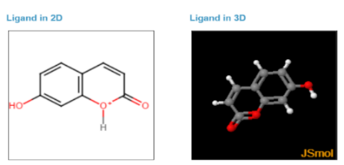

Tinosporide
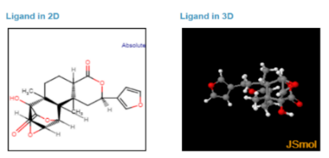

Tembetarine
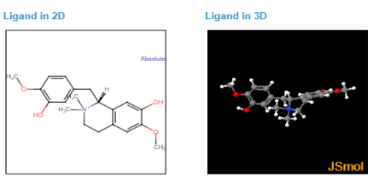

Linoleic acid
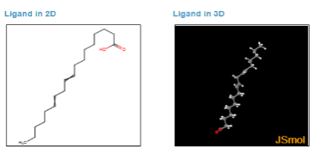

Kaempferol
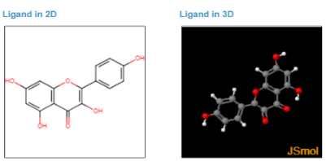

Sitagliptin
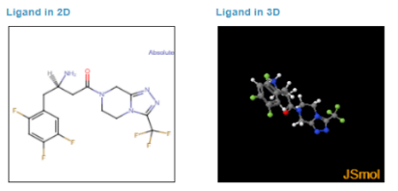

GSK-3β Inhibitor VII
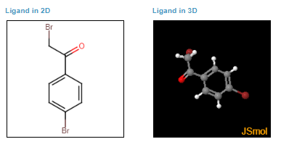

Limonene
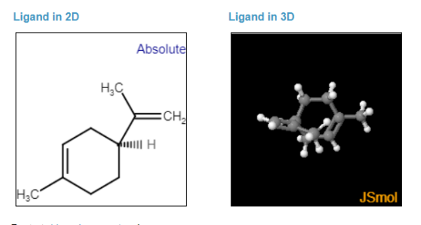

β-phellandrene
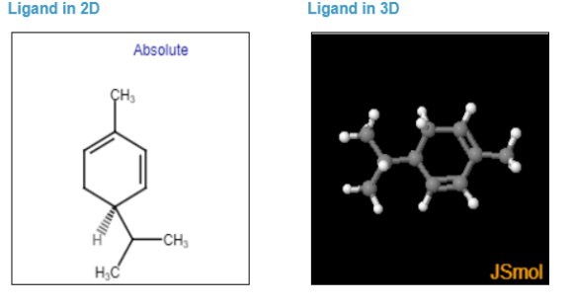
Acarbose
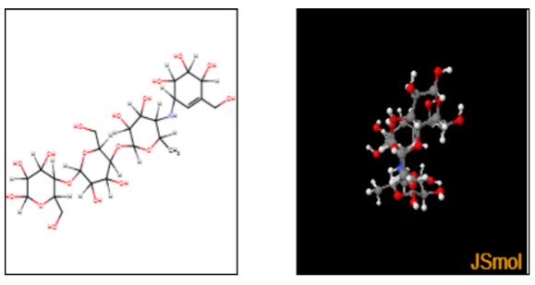

Table 3. Ligand Properties of the Compounds Selected for Docking Analysis
Compound | Molar weight g/mol | Molecular Formula | H Bond Donor | H Bond Acceptor | Rotatable bonds
Tinosporide | 374.4 g/mol | C₂₀H₂₂O₇ | 1 | 7 | 1
Tembetarine | 344.4 g/mol | C₂₀H₂₆NO₄₊ | 2 | 4 | 4
 | 136.23 g/mol | C₁₀H₁₆ | 0 | 0 | 1
 | 136.23 g/mol | C₁₀H₁₆ | 0 | 0 | 1
α-Humulene | 204.35 g/mol | C₁₅H₂₄ | 0 | 0 | 0
Salacinol | 334.354 g/mol | C₉H₁₈O₉S₂ | 5 | 9 | 6
Kotalanol | 424.4 g/mol | C₁₂H₂₄O₁₂S₂ | 8 | 12 | 9
Nimbolide | 466.5 g/mol | C₂₇H₃₀O₇ | 0 | 7 | 4
Nimbiol | 272.4g/mol | C₁₈H₂₄O₂ | 1 | 2 | 0
Linoleic acid | 280.452 g/mol | C₁₈H₃₂O₂ | 1 | 2 | 14
Kaempferol | 286.24 g/mol | C₁₅H₁₀O₆ | 4 | 6 | 1
Acarbose | 645.608 g/mol | C₂₅H₄₃NO₁₈ | 14 | 19 | 9
Sitagliptin | 407.31 g/mol | C₁₆H₁₅F₆N_{5O} | 1 | 10 | 4
GSK-3β Inhibitor VII | 277.94 g/mol | C₈H₆Br₂O | 0 | 1 | 2

Docking observations
Docking of phytocompounds against Human dipeptidyl peptidase IV with PDB- 2P8S
Dipeptidyl peptidase hormones are recognized for their ability to stimulate the release of insulin through meal signaling. The upregulation of DDP4 in individuals with diabetes tends to directly inhibit the action of GIP and GLP, resulting in a decrease in insulin production and ultimately leading to hyperglycemia. Binding of phytocomponents with the core amino acids (Try226, Glu205, Glu206, Try547, Try667, Asn710, Val711, His740, Ser630, Ser 209, Arg358, Phe357, and Val207) of the target by forming hydrogen bond will hinder the function of the target protein enzyme Human dipeptidyl peptidase IV with PDB- 2P8S. DPP4 can degrade physiologically important gastrointestinal hormones such as glucagon-like peptides (GLP) and other gastric inhibitory polypeptides (GIP). The 3D structure of human dipeptidyl peptidase IV is given in figure 2.

Figure 2. 3D- Structure of Human dipeptidyl peptidase IV with PDB- 2P8S
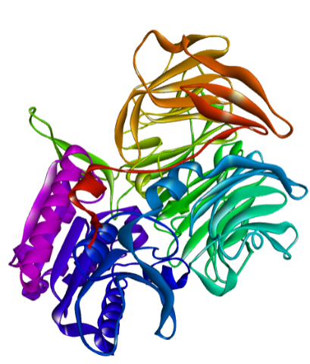

The docking of the enzyme Dipeptidyl peptidase IV with the phytochemicals such as Salacinol, Nimbolide, Nimbiol, Umbelliferone, Tinosporide, Tembetarine, Linoleic acid and Kaempferol revealed a maximum of five to seven interactions with the core active amino acid residues in comparison with the standard Sitagliptin with 10 interactions. The overall summary of the docking studies and the amino acid interactions with the compounds are mentioned in table 4 & 5.

Table 4. Summary of the molecular docking studies of phytocompounds against Human dipeptidyl peptidase IV with PDB- 2P8S
Compound | Est. Free Energy of Binding | Est. Inhibition Constant, Ki | Electrostatic Energy | Total Intermolec. Energy | Interact. Surface
Salacinol | -7.68 kcal/mol | 2.35 uM | -1.04 kcal/mol | -4.72 kcal/mol | 546.849
Kotalanol | -10.22 kcal/mol | 32.42 nM | -0.94 kcal/mol | -4.77 kcal/mol | 599.763
Nimbolide | -6.26 kcal/mol | 25.93 uM | -0.19 kcal/mol | -7.04 kcal/mol | 763.564
Nimbiol | -6.35 kcal/mol | 22.32 uM | -0.17 kcal/mol | -6.64 kcal/mol | 654.894
α-Humulene | -5.43 kcal/mol | 104.92 uM | -0.06 kcal/mol | -5.43 kcal/mol | 534.047
Umbelliferone | -4.85 kcal/mol | 278.00 uM | -0.24 kcal/mol | -5.15 kcal/mol | 412.489
Tinosporide | -6.20 kcal/mol | 28.45 uM | -0.22 kcal/mol | -6.78 kcal/mol | 735.481
Tembetarine | -7.59 kcal/mol | 2.73 uM | -1.00 kcal/mol | -8.13 kcal/mol | 738.388
Linoleic acid | -5.21 kcal/mol | 151.28 uM | -0.07 kcal/mol | -8.62 kcal/mol | 766.758
Kaempferol | -5.42 kcal/mol | 106.24 uM | -0.01 kcal/mol | -5.77 kcal/mol | 641.86
Sitagliptin | -10.93 kcal/mol | 9.76 nM | -2.68 kcal/mol | -11.56 kcal/mol | 714.365

Table 5. Amino acid Residue Interaction of phytocompounds against Human dipeptidyl peptidase IV with PDB- 2P8S and standard Sitagliptin
Compounds | Interactions | Amino Acid Residues
Salacinol | 5 | 125 | 205 | 206 | 209 | 357 | 547 | 666
 |  | ARG | GLU | GLU | SER | PHE | TYR | TYR
Kotalanol | 4 | 125 | 205 | 206 | 209 | 357 | 662 | 666
 |  | ARG | GLU | GLU | SER | PHE | TYR | TYR
Nimbolide | 6 | 125: ARG126: HIS205: GLU206: GLU209: SER357: PHE547: TYR552: SER662: TYR 666: TYR
 |  |  | 205 | 206 | 357 | 547
Nimbiol | 7 | 125 | GLU | GLU | PHE | TYR | 630 | 631 | 662 | 666 | 710 | 711
 |  | ARG | 124 | 125 | 709 | 710 | SER | TYR | TYR | TYR | ASN | VAL
α-Humulene | 2 | 122 | TRP | ARG | ASP | ASN | 739 | 740
 |  | LYS | 205 | 206 | 630 | 631 | ASP | HIS
Umbelliferone | 6 | 125 | GLU | GLU | SER | TYR | 656 | 659 | 662 | 666 | 710 | 711 | 740
 |  | ARG | 205 | 206 | 209 | 357 | VAL | TRP | TYR | TYR | ASN | VAL | HIS
Tinosporide | 9 | 125 | GLU | GLU | SER | PHE | 358 | 547 | 630 | 662 | 666 | 710 | 740
 |  | ARG | 205 | 206 | 357 | 547 | ARG | TYR | SER | TYR | TYR | ASN | HIS
Tembetarine | 6 | 125 | GLU | GLU | PHE | TYR | 552 | 630 | 631 | 656 | 659 | 662 | 666 | 711
 |  | ARG | 205 | 206 | 209 | 357 | SER | SER | TYR | VAL | TRP | TYR | TYR | VAL
Linoleic acid | 7 | 125 | GLU | GLU | SER | PHE | 358 | 547 | 630 | 631 | 656 | 659 | 662 | 666 | 669
 |  | ARG | 206 | 209 | 357 | 547 | ARG | TYR | SER | TYR | VAL | TRP | TYR | TYR | ARG
Kaempferol | 7 | 125 | GLU | SER | PHE | TYR | 630 | 656 | 662 | 666 | 669 | 711 | 740
 |  | ARG |  |  |  |  |  | VAL | TYR | TYR | ARG | VAL | HIS

Docking of phytocompounds against Glycogen synthase kinase beta 3D- PDB- 1Q3W
GSK-3β is recognized for its ability to impede the function of insulin by phosphorylating and rendering inactive insulin receptor substrate-1 (IRS-1), a pivotal mediator of insulin signaling. Binding of phytocomponents with the core amino acids (62 ILE ,85 LYS, Glu97, Asp133,134 TYR ,135 VAL, 200 ASP) of the target by forming hydrogen bond will hinder the function of the target protein enzyme Glycogen synthase kinase beta with PDB- 1Q3W (Fig.3)

Figure 3. 3-D Structure of Glycogen synthase kinase beta with PDB- 1Q3W
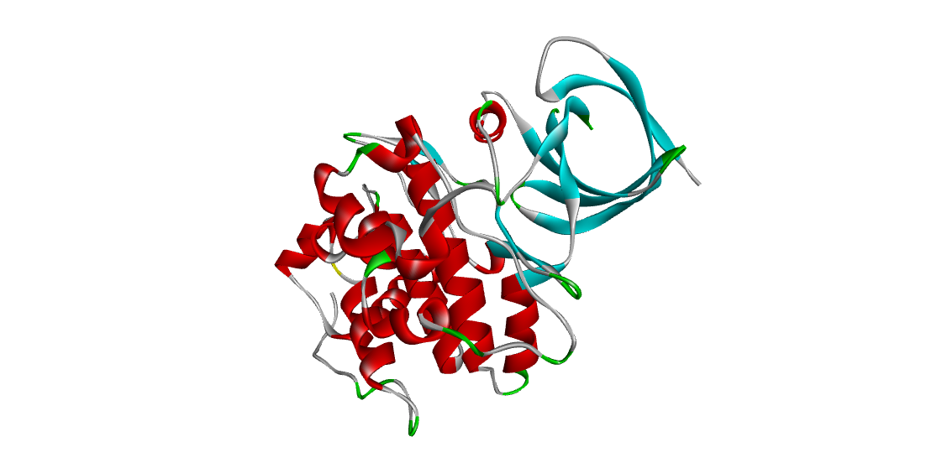

In the case of GSK-3β docking with the phytochemicals Kotalanol, Tembetarine, Linoleic acid and Kaempferol exhibited a maximum of three to four interactions with the core active amino acid residues present on the target enzyme GSK-3β in comparison with the standard GSK-3β Inhibitor VII. The overall docking results and the amino acids that interacted are represented table 6 &7.

Table 6. Summary of the molecular docking studies of compounds against Glycogen synthase kinase beta with PDB- 1Q3W
Compound | Est. Free Energy of Binding | Est. Inhibition Constant, Ki | Electrostatic Energy | Total Intermolec. Energy | Interact. Surface
Salacinol | -8.09 kcal/mol | 1.18 uM | -0.15 kcal/mol | -4.58 kcal/mol | 587.819
Kotalanol | -11.91 kcal/mol | 1.88 nM | -0.63 kcal/mol | -5.58 kcal/mol | 732.42
Nimbolide | -6.91 kcal/mol | 8.64 uM | -0.02 kcal/mol | -7.88 kcal/mol | 879.799
Nimbiol | -6.67 kcal/mol | 12.95 uM | -0.03 kcal/mol | -6.97 kcal/mol | 642.708
α-Humulene | -6.36 kcal/mol | 21.73 uM | -0.01 kcal/mol | -6.36 kcal/mol | 548.018
Umbelliferone | -4.52 kcal/mol | 490.04 uM | -0.04 kcal/mol | -4.81 kcal/mol | 440.885
Tinosporide | -6.60 kcal/mol | 14.56 uM | -0.08 kcal/mol | -7.05 kcal/mol | 723.374
Tembetarine | -6.49 kcal/mol | 17.47 uM | -0.28 kcal/mol | -7.32 kcal/mol | 769.153
Linoleic acid | -6.08 kcal/mol | 34.90 uM | -0.61 kcal/mol | -8.51 kcal/mol | 658.923
Kaempferol | -6.61 kcal/mol | 14.20 uM | -0.28 kcal/mol | -7.08 kcal/mol | 602.064
GSK-3β Inhibitor VII | -4.94 kcal/mol | 239.21 uM | -0.01 kcal/mol | -5.35 kcal/mol | 393.987

Table 7. Amino acid Residue Interaction of Lead against Glycogen synthase kinase beta with PDB- 1Q3W
Compounds | Interactions | Amino Acid Residues
Salacinol | 2 | 62 | 70 | 83 | 134 | 138 | 188 | 199
 |  | ILE | VAL | ALA | TYR | THR | LEU | CYS
Kotalanol | 3 | 62 | 134 | 138 | 185 | 186 | 188 | 199 | 200
 |  | ILE | TYR | THR | GLN | ASN | LEU | CYS | ASP
Nimbolide | 2 | 70 | 85 | 138 | 140 | 185 | 186 | 188 | 199 | 200
 |  | VAL | LYS | THR | TYR | GLN | ASN | LEU | CYS | ASP
Nimbiol | 2 | 62 | 70 | 83 | 110 | 132 | 134 | 188 | 199
 |  | ILE | VAL | ALA | VAL | LEU | TYR | LEU | CYS
α-Humulene | 2 | 70 | 83 | 85 | 110 | 132 | 134 | 188 | 199
 |  | VAL | ALA | LYS | VAL | LEU | TYR | LEU | CYS
Umbelliferone | 1 | 83 | 110 | 132 | 134 | 188 | 199
 |  | ALA | VAL | LEU | TYR | LEU | CYS
Tinosporide | 2 | 62 | 70 | 83 | 110 | 132 | 134 | 138 | 141 | 188 | 199
 |  | ILE | VAL | ALA | VAL | LEU | TYR | THR | ARG | LEU | CYS
Tembetarine | 4 | 62 | 83 | 85 | 97 | 110 | 132 | 134 | 138 | 141 | 188 | 199 | 200
 |  | ILE | ALA | LYS | GLU | VAL | LEU | TYR | THR | ARG | LEU | CYS | SP
Linoleic acid | 4 | 70 | 83 | 85 | 97 | 110 | 132 | 134 | 188 | 199 | 200
 |  | VAL | ALA | LYS | GLU | VAL | LEU | TYR | LEU | CYS | ASP
Kaempferol | 3 | 83 | 85 | 97 | 110 | 132 | 134 | 138 | 188 | 199
 |  | ALA | LYS | GLU | VAL | LEU | TYR | THR | LEU | CYS
GSK-3β Inhibitor VII | 4
83 | 85 | 97 | 101 | 110 | 132 | 133 | 134 | 188 | 199
ALA | LYS | GLU | MET | VAL | LEU | ASP | TYR | LEU | CYS

Docking of phytocompounds against alpha-glucosidase (PDB) - 4J5T

The enzyme alpha-glucosidase (PDB) - 4J5T (figure 4) hydrolyses starch to release sugar moieties and triggers the blood glucose levels. The binding of phytocomponents with the core amino acids (Asp568, Tyr709, Glu771, Asp392 and Arg428) of the target by forming hydrogen bond will hinder the function of the target protein enzyme.

Figure 4. 3D- Structure of Alpha-Glucosidase (PDB) - 4J5T
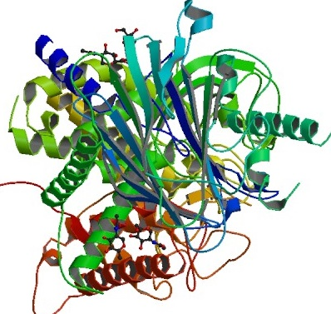

The enzyme Alpha-glucosidase interaction with the phytochemicals Tinosporide, Tembetarine, Salacinol, Kotalanol, Nimbolide, Nimbiol, Linoleic acid and Kaempferol showed a maximum of four to five interactions with the core active amino acid residues present on the target enzyme Alpha-Glucosidase in comparison with standard acarbose with the maximum of 5 interactions. The summary of the docking results and the amino acid interactions are mentioned in table 8 & 9.

Table 8. Summary of the molecular docking studies of compounds against Alpha-Glucosidase (PDB) - 4J5T
Compound | Est. Free Energy of Binding | Est. Inhibition Constant, Ki | Electrostatic Energy | Total Intermolec. Energy | Interact. Surface
Tinosporide | -7.64 kcal/mol | 2.52 uM | -0.20 kcal/mol | -8.03 kcal/mol | 679.884
Tembetarine | -7.61 kcal/mol | 2.63 uM | -1.63 kcal/mol | -8.08 kcal/mol | 802.768
Limonene | -4.95 kcal/mol | 234.91 uM | -0.15 kcal/mol | -5.25 kcal/mol | 432.601
β-phellandrene | -5.29 kcal/mol | 132.25 uM | -0.01 kcal/mol | -5.59 kcal/mol | 441.711
α-Humulene | -6.47 kcal/mol | 18.11 uM | -0.01 kcal/mol | -6.47 kcal/mol | 553.736
Salacinol | -10.68 kcal/mol | 14.96 nM | -2.04 kcal/mol | -8.25 kcal/mol | 582.093
Kotalanol | -12.55 kcal/mol | 629.78 pM | -0.43 kcal/mol | -6.76 kcal/mol | 681.614
Nimbolide | -8.51 kcal/mol | 578.81 nM | -0.19 kcal/mol | -9.38 kcal/mol | 846.27
Nimbiol | -6.83 kcal/mol | 9.81 uM | -0.36 kcal/mol | -7.13 kcal/mol | 638.356
Linoleic acid | -5.22 kcal/mol | 150.40 uM | -0.83 kcal/mol | -8.01 kcal/mol | 708.338
Kaempferol | -4.77 kcal/mol | 320.37 uM | -0.53 kcal/mol | -5.16 kcal/mol | 635.444
Acarbose | -13.98 kcal/mol | 56.82 pM | -1.31 kcal/mol | -9.69 kcal/mol | 801.21

Table 9. Amino acid Residue Interaction of Lead against Alpha-Glucosidase (PDB) - 4J5T
Compounds | Interactions | Amino acid residues
Tinosporide | 5 | 385: PHE389: PHE391: TRP392: ASP428: ARG568: ASP709: TYR710: TRP715: TRP771: GLU789: TRP
Tembetarine | 5 | 385: PHE389: PHE391: TRP392: ASP428: ARG429: GLU561: HIS568: ASP569: ASP707: GLU709: TYR710: TRP715: TRP771: GLU789: TRP
Limonene | 2 | 380: PRO385: PHE389: PHE391: TRP392: ASP710: TRP715: TRP771: GLU786: PHE789: TRP
β-phellandrene | 2 | 380: PRO385: PHE389: PHE391: TRP392: ASP710: TRP715: TRP771: GLU786: PHE789: TRP
α-Humulene | 3 | 385: PHE389: PHE391: TRP392: ASP428: TYR710: TRP715: TRP771: GLU786: PHE789: TRP
Salacinol | 5 | 380: PRO385: PHE389: PHE391: TRP392: ASP428: ARG563: LEU568: ASP709: TYR710: TRP715: TRP771: GLU786: PHE789: TRP
Kotalanol | 5 | 380: PRO385: PHE389: PHE391: TRP392: ASP428: ARG563: LEU568: ASP709: TYR710: TRP715: TRP771: GLU786: PHE789: TRP
Nimbolide | 5 | 380: PRO385: PHE389: PHE391: TRP392: ASP428: ARG429: GLU563: LEU568: ASP569: ASP707: GLU709: TYR710: TRP715: TRP771: GLU786: PHE789: TRP
Nimbiol | 4 | 380: PRO385: PHE389: PHE392: ASP568: ASP709: TYR710: TRP715: TRP771: GLU786: PHE789: TRP
Linoleic acid | 4 | 380: PRO385: PHE389: PHE391: TRP392: ASP428: ARG709: TYR710: TRP715: TRP771: GLU786: PHE789: TRP
Kaempferol | 4 | 385: PHE387: ARG389: PHE392: ASP428: ARG429: GLU440: VAL444: PHE710: TRP771: GLU786: PHE789: TRP
Acarbose | 5 | 385 PHE, 387 ARG, 391 TRP, 392 ASP, 428 ARG, 429 GLU, 440 VAL, 441 PRO, 444 PRO, 563 LEU, 566 GLY, 568 ASP, 709 TYR, 710 TRP, 715 TRP, 771 GLU, 789 TRP

    - Docking of phytocompounds against alpha-amylase PDB- 1HNY
The enzyme pancreatic alpha-amylase PDB- 1HNY (Figure 5) hydrolyses starch into sugar molecules and increases the blood glucose levels. Binding of phytocomponents with the core amino acids (Trp 58, Trp 59, Tyr 62, His 101, Leu 162, Arg 195, Asp 197, Ala 198, Ser 199, Lys 200, His 201, Glu 233, Asp 300) of the target by forming hydrogen bond will hinder the function of the target protein enzyme human.

Figure 5. 3D- Structure of Human pancreatic alpha-amylase – 1HNY
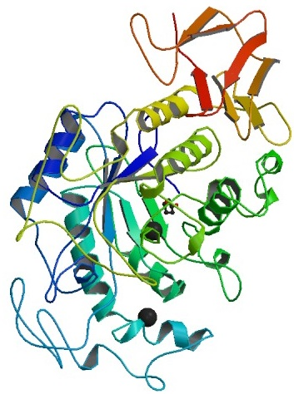

The docking study of the enzyme Alpha-amylase with the phytochemicals such as Tinosporide, Salacinol, Kotalanol, Nimbolide and Linoleic acid revealed a maximum of eight to ten interactions with the core active amino acid residues. Following these compounds such as Tembetarine, α-Humulene, Nimbiol and Kaempferol ranked second with a maximum of five to seven interactions with the active site of the target enzyme Alpha-amylase in comparison with the standard Acarbose with 11 interactions. The docking summary and the amino acid residues involved are mentioned in table 10 & 11.

Table 10. Summary of the molecular docking studies of compounds against Alpha-Amylase (PDB) – 1HNY
Compound | Est. Free Energy of Binding | Est. Inhibition Constant, Ki | Electrostatic Energy | Total Intermolec. Energy | Interact. Surface
Tinosporide | -6.50 kcal/mol | 17.23 uM | -0.68 kcal/mol | -6.89 kcal/mol | 710.006
Tembetarine | -7.26 kcal/mol | 4.80 uM | -1.74 kcal/mol | -7.71 kcal/mol | 778.891
Limonene | -4.42 kcal/mol | 574.98 uM | -0.09 kcal/mol | -4.72 kcal/mol | 435.784
β-phellandrene | -4.55 kcal/mol | 459.77 uM | -0.01 kcal/mol | -4.85 kcal/mol | 450.205
α-Humulene | -6.26 kcal/mol | 25.80 uM | -0.00 kcal/mol | -6.26 kcal/mol | 562.152
Salacinol | -9.48 kcal/mol | 112.74 nM | -1.39 kcal/mol | -5.95 kcal/mol | 590.298
Kotalanol | -11.59 kcal/mol | 3.18 nM | -0.95 kcal/mol | -4.92 kcal/mol | 621.682
Nimbolide | -7.62 kcal/mol | 2.60 uM | -0.22 kcal/mol | -8.33 kcal/mol | 783.937
Nimbiol | -6.68 kcal/mol | 12.62 uM | -0.25 kcal/mol | -6.98 kcal/mol | 634.43
Linoleic acid | -5.23 kcal/mol | 147.62 uM | -0.28 kcal/mol | -8.85 kcal/mol | 791.556
Kaempferol | -5.13 kcal/mol | 174.04 uM | -0.63 kcal/mol | -5.53 kcal/mol | 483.564
Acarbose | -13.44 kcal/mol | 141.91 pM | -0.70 kcal/mol | -8.01 kcal/mol | 945.004

Table 11. Amino acid Residue Interaction of Lead against Alpha-amylase (PDB) – 1HNY
Compound | Interactions |  | Amino acid Residue
Tinosporide | 9 | 58: TRP62: TYR162: LEU165: LEU197: ASP198: ALA200: LYS201: HIS233: GLU235: ILE300: ASP
Tembetarine | 6 | 58: TRP59: TRP62: TYR63: GLN197: ASP233: GLU235: ILE299: HIS300: ASP305: HIS
Limonene | 3 | 59: TRP62: TYR63: GLN101: HIS165: LEU
β-phellandrene | 4 | 58: TRP62: TYR162: LEU165: GLN197: ILE299: HIS300
α-Humulene | 6 | 58: TRP59: TRP62: TYR63: HIS101:162 LEU:165 LEU:197 ASP: ILE299: HIS300
Salacinol | 8 | 58: TRP59: TRP62: TYR63: GLN162: LEU165: LEU197: ASP198: ALA233: GLU300: ASP
Kotalanol | 8 | 59: TRP62: TYR63: GLN162: LEU165: LEU197: ASP198: ALA233: GLU299: HIS300: ASP
Nimbolide | 9 | 58: TRP62: TYR162:HIS101:162 LEU:THR163: LEU165:ARG195: LEU197: HIS233:HIS299: ILE300: ASP:305 HIS
Nimbiol | 7 | 58: TRP59: TRP62: TYR63: GLN163: THR165: LEU197: ASP198: ALA233: GLU300: ASP
Linoleic acid | 10 | 58: TRP59: TRP62: TYR63: 151 TYR:162 LEU: GLN197:198 ALA:200 LYS:201 HIS: ASP233: GLU235: ILE299: HIS300
Kaempferol | 5 | 151 TYR:162 LEU:163 THR:198 ALA:200 LYS:201 HIS:233 GLU:235 ILE
Acarbose | 11 | 58 TRP |  | 62 TYR | 162 LEU |  | 163 THR |  | 165 LEU |  | 197 ASP |  | 198 ALA |  | 233 GLU |  |  | 235ILE |  | 300 ASP |  | 305 HIS |  | 307 ALA

Conclusion:

Based on the results of the computational analysis it was concluded that bio-active compound’s like Salacinol, Nimbolide, Nimbiol, Umbelliferone, Tinosporide, Tembetarine, Linoleic acid and Kaempferol exhibited significant binding affinity against Dipeptidyl peptidase IV, Glycogen synthase kinase, Alpha glucosidase and Alpha amylase enzyme by interacting with active amino acid present on the active site. Thereby, the interaction of Dipeptidyl peptidase IV with the phytocompounds will prevent the degradation of important gastrointestinal hormones such as glucagon-like peptides (GLP) and other gastric inhibitory polypeptides (GIP). The interaction of glycogen synthase kinase beta would promote the function of insulin by phosphorylating and rendering active insulin receptor substrate-1 (IRS-1). The interaction of Alpha-Glucosidase and Alpha-amylase with the phytocompounds might exert promising anti-diabetic activity by inhibiting the action of the enzyme Alpha-Glucosidase and preventing conversion of starch in to glucose thereby reduce the blood glucose level.
It is concluded that the selected phytocomponents of MKC may act as a potential therapeutic agent for the management of diabetes.

Acknowledgement
I am blessed to express my sincere gratitude towards Our Asan Palpandian, Thiruvannamalai who guided me throughout.

Statement of Ethical Approval and Informed Consent
This work does not involve animal testing and does not require ethical approval. Informed consent of all authors has been obtained for this work.

Declaration of Conflicting Interests
The authors declared no potential conflicts of interest with respect to the research, authorship, and/or publication of this article.

Funding
Self sponsored.

References:

- Alzohairy, Mohammad A. 2016. “Therapeutics Role of Azadirachta Indica (Neem) and Their Active Constituents in Diseases Prevention and Treatment.” Evidence-based Complementary and Alternative Medicine 2016.
- Dr.R.S. Lekshmi1, Dr.K. Jawaharrani2, Dr.J.Srilekha3, Mr.Suresh.K. 2023. “FAMILIARITY EXPERIENCE AND PREFERENCE FOR SIDDHA TREATMENT.” Journal of Pharmaceutical Negative Results 14(02): 1823–32.
- Krupanidhi, S. et al. 2020. “Screening of Phytochemical Compounds of Tinospora Cordifolia for Their Inhibitory Activity on SARS-CoV-2: An in Silico Study.” Journal of Biomolecular Structure and Dynamics: 1–5.
- Lakshmanakumar, Venkatachalam et al. 2023. “Molecular Docking Analysis to Validate the Efficacy of Traditional Siddha Polyherbal Formulation Aavarai Bhavanai Chooranam (ABC) against Enzyme Alpha-Glucosidase for Type II Diabetes Mellitus.” TMR Integrative Medicine 7(0): e23001.
- Maiti, Suraj, Shamrin Akhtar, Ashish Kumar Upadhyay, and Sanjay K. Mohanty. 2023. “Socioeconomic Inequality in Awareness, Treatment and Control of Diabetes among Adults in India: Evidence from National Family Health Survey of India (NFHS), 2019–2021.” Scientific Reports 13(1): 1–12. https://doi.org/10.1038/s41598-023-29978-y.
- Mandal, Sumit Kumar et al. 2023. “In Silico Anti-Viral Assessment of Phytoconstituents in a Traditional (Siddha Medicine) Polyherbal Formulation – Targeting Mpro and Pan-Coronavirus Post-Fusion Spike Protein.” Journal of Traditional and Complementary Medicine 14(1): 55–69.
- Mudaliyar, Vaithiya Rathnam K. S. Murugesa. “No Title.” In Gunapadam Medicinal Plants Division, Directorate of Indian Medicine and Homeopathy, , p147.
- New Delhi, Govt.of India, Ministry of Health and Family welfare, Department of AYUSH. 2011. Siddha Pharmacopoeia of India Part 1 Vol 2 First Edition.
- Oboh, Ganiyu, Adelusi Temitope Isaac, Ayodele Jacobson Akinyemi, and Richard Akinlolu Ajani. 2014. “Inhibition of Key Enzymes Linked to Type 2 Diabetes and Sodium Nitroprusside Induced Lipid Peroxidation in Rats’ Pancreas by Phenolic Extracts of Avocado Pear Leaves and Fruit.” International Journal of Biomedical Science 10(3): 210–18.
- Palpandian, .Asan R. 2019. 2nd Edition Siddhas Masters of Nature, Devotees of Sri Sri Ravi Shankar Ashram.
- Palpandian. Asan R. Nature Mmics, Thiruvannamalai, Earth India Siddha Private Limited, Tamilnadu, ISBN: 978-935351093
- Ponnusamy, Revathi et al. 2022. “Glycogen Synthase Kinase 3β Inhibition and Insulin-Receptor Binding Enhancement of Compounds Isolated from Wild Leafy Vegetable Acalypha Alnifolia.” Phytomedicine Plus 2(1): 1–22.
- Rahman, Shahedur, and Rashida Parvin. 2014. “Therapeutic Potential of Aegle Marmelos (L.)-An Overview.” Asian Pacific Journal of Tropical Disease 4(1): 71–77.
- Rahmani, Arshad H. 2015. “Cassia Fistula Linn: Potential Candidate in the Health Management.” Pharmacognosy Research 7(3): 217–24.
- Raut, Bimal K., Siddha Raj Upadhyaya, Jyoti Bashyal, and Niranjan Parajuli. 2023. “In Silico and In Vitro Analyses to Repurpose Quercetin as a Human Pancreatic α-Amylase Inhibitor.” ACS Omega 8(46): 43617–31.
- Saravana Babu, Chidambaram et al. 2012. “Polyphenols in Madhumega Chooranam, a Siddha Medicine, Ameliorates Carbohydrate Metabolism and Oxidative Stress in Type II Diabetic Rats.” Journal of Ethnopharmacology 142(2): 331–36.
- Sujata, Basu, Mamta Pant, and Rachana. 2013. “Phytochemical Evaluation and Hptlc Profiling of Extracts of Salacia Oblonga.” International journal of Pharmaceutical Sciences and Research 4(4): 1409–18.

